**30.12.2022**

Bogna Kilanowska

Zuzanna Buchnajzer

***Computer Vision: Project 2.***

*Board Game: “Role Player”*

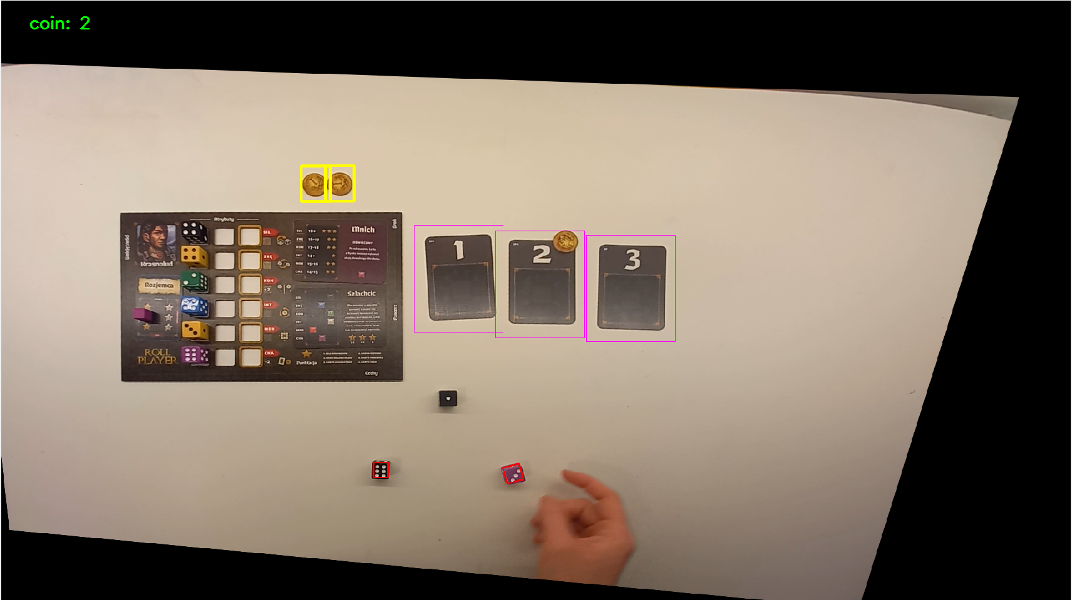

# Game *Roll Player*

In our version this is a one-person game. In each round the player rolls three dice and puts them on top of cards. Next, he chooses one of the cards and places one die on his character sheet. In the next step, the player can make a purchase on the market using coins he owns. The player obtains coins by drawing the yellow die or by choosing the initiative card with number 2. The game finishes when all die spots are occupied by dice. The score is the sum of face values of the dice and the count of dice in the player’s own assigned color.

In our project we capture:

* 1. adding a coin to the inventory (detection)
  2. the movement of cards (detection and tracking)
  3. dice roll (detection)

# Datasets

Unfortunately, each of the difficulty levels has at least mild camera distortion, lighting is uneven and, worst of all, sometimes elements are partially covered by the hand while recording gameplay.

* + **easy**: the lighting is constant, no significant shadows, little camera tilt

* + **medium**: the illumination changes (turning the extra light on and off), and the shadows are mainly on the sides as well as during hand movement or dice throwing.

* + **hard**: the lighting is constant, but the image is very distorted.

# Calibration

As we noticed, each video has a different distortion, so we applied calibration to each dataset.

Our main goal was to find the player's board and then change its position along with the entire image so that the board instead of a foursome was a rectangle.

|  |  |
| --- | --- |
|  |  |

Problems we encountered:

- We had to label the corners in the right order, otherwise the mapping was wrong.

- The contour was not continuous, so we had to blur more than once or play with parameters.

|  |  |
| --- | --- |
|  |  |

1. **Detecting game elements**

* **Cards**

We detect the cards every few frames of the video using a template, but in between, we use a tracker.

Unfortunately, since it is common to put dice on the cards, remove coins, and move them around, those detections regardless of the dataset do not perform well.

|  |  |
| --- | --- |
|  |  |

* **Coins**

Coins are detected using a template only in the upper left part of the video to speed up time. It can be seen that on the second card lies a coin, but it will not be captured anyway, because it lies partially on the dark card, so it does not pass the threshold border.

Money detection works very well for any dataset. Sometimes a coin may disappear for a while, but we don't track them because they aren't moved much.

* **Dice**

We are looking for a dice roll in the region between the middle of the player board and the lowest card. To find the contours we use adaptive threshold and morphology operations. Then, we check the size of the rectangle described on it and see if its size coincides more or less with the expected dimensions of the dice.

Unfortunately, the dice detection does not work perfectly. Due to the fact that a hand is shown on the dice-throwing area, the results are not very good. Sometimes dice are also too close and overlap, then I can't detect them accurately either.

# Conclusions

It turned out that after solving the problem with the appropriate angle, all datasets performed similarly. The biggest problem we discovered during our writing of the project is definitely the hand covering of the elements. We didn't find that light and shadow played a big role.

# Final thoughts

During the writing of this project, we discovered a number of problems that we did not initially pay much attention to. It turned out that it's not easy to record a video where the elements are not covered by anything, nor to get good lighting late at night.

Although the results can definitely be improved, we are still very impressed by what a broad range of skills we were able to use here. more than once we used different blurring before edge detection. We used Canny and adaptive thresholding accordingly. We performed aware morphological operations such as opening and eroding with various types of kernels. On top of that, we finally understood many methods in depth like getPerspectiveTransform, warpPerspective, or goodFeaturesToTrack and more. We worked on whole images, sections, and mapped images. Although the project didn't seem difficult, the problems along the way made it challenging and we will certainly remember it for a long time.